# Photo selection for Turkish concepts

In this task, you need to select photos containing certain concepts (in Turkish). You need to be a native Turkish speaker to participate.

As an example annotation prompt, “[[[Basketbol]]]” in the annotation form (at the bottom) requires you to write **12** links to photos containing “Basketbol”. The key requirement for selecting the photos is to ensure that they are **commonly found or representative in the Turkish speaking population**. Try to select photos that are **as unique to your culture as possible**. E.g., for “Basketbol”, the first photo is preferred for Turkish since it reflects the Basketbol-speaking people’s lives (while the second photo is taken in the US).

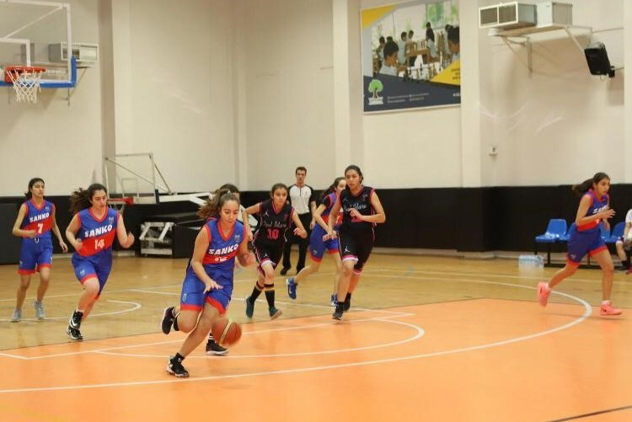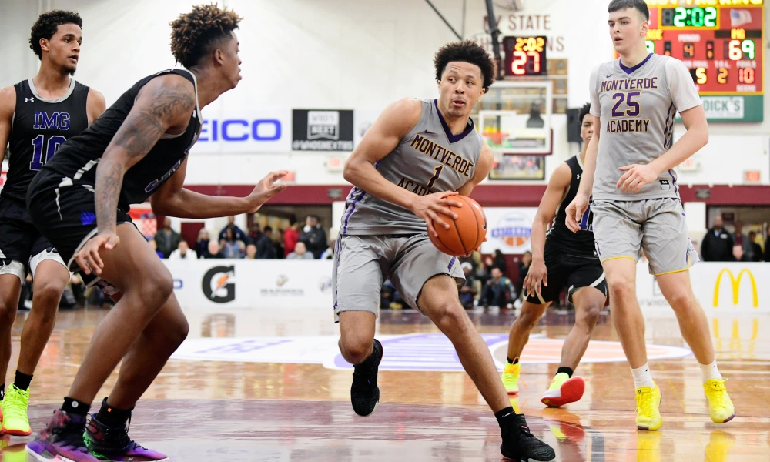

We pay annotators based on the number of qualified photos. So, please read carefully the following guidelines (starting next page).

For each valid link/photo, we pay 0.12 GBP. We aim to collect photos for concepts, and 12 photos per concept. If you believe you cannot collect enough qualified photos for any concept, please feel free to collect fewer than 12.

The selected photos should satisfy at least **one of the four criteria** listed in the table below (the more the better).

To diversify the photos, **feel free to modify the query** you used (e.g., for “dog”, you could search for “a group of dogs”, “dogs running”, etc.)

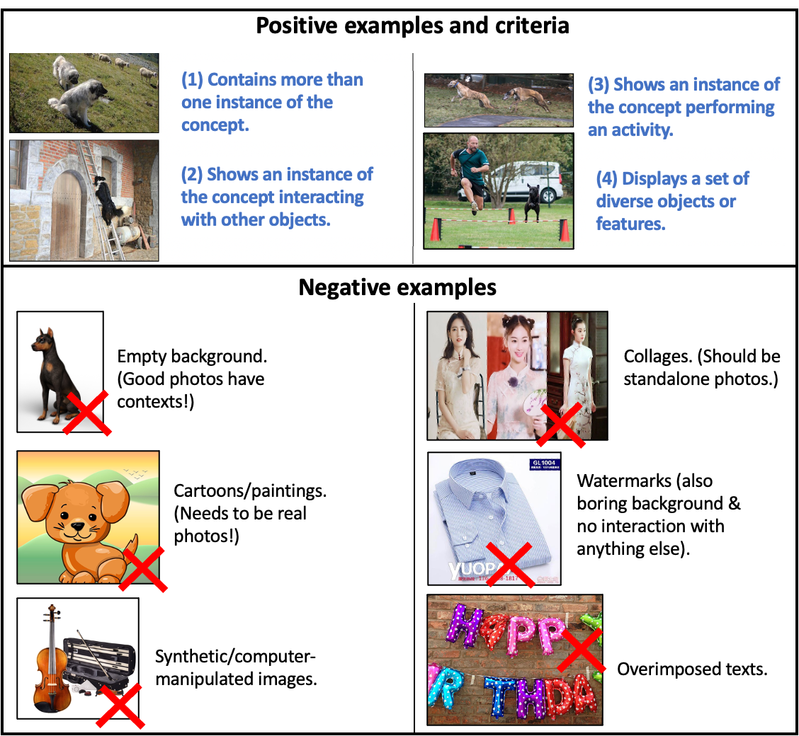

**Further notes:**

* Avoid photos showing **violence** or **death**.
* Photos should reflect what’s commonly seen in your culture! E.g. for photos of “suits”, an Indian annotator should try to find photos with Indians wearing suits:

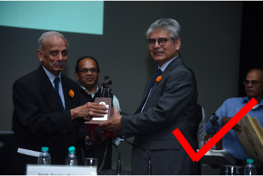 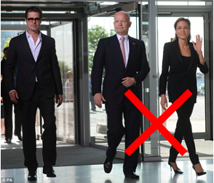

(In order to find desired photos, be creative with the query used! You can search for “business meeting India” instead of simply “suits” here.)

* For each concept, **avoid** selecting multiple photos that look **too similar**:

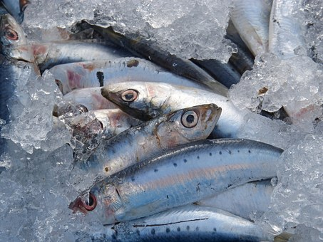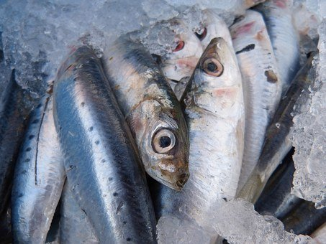 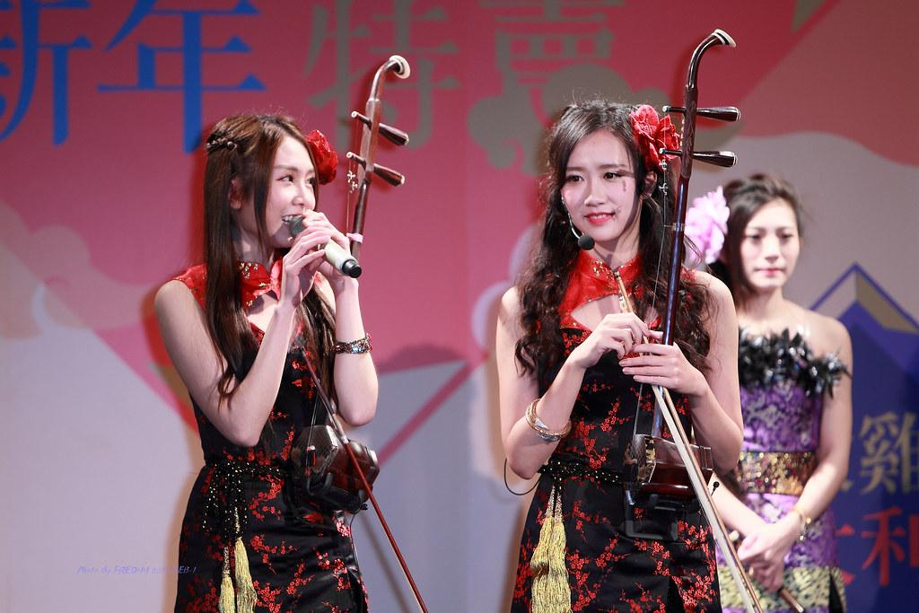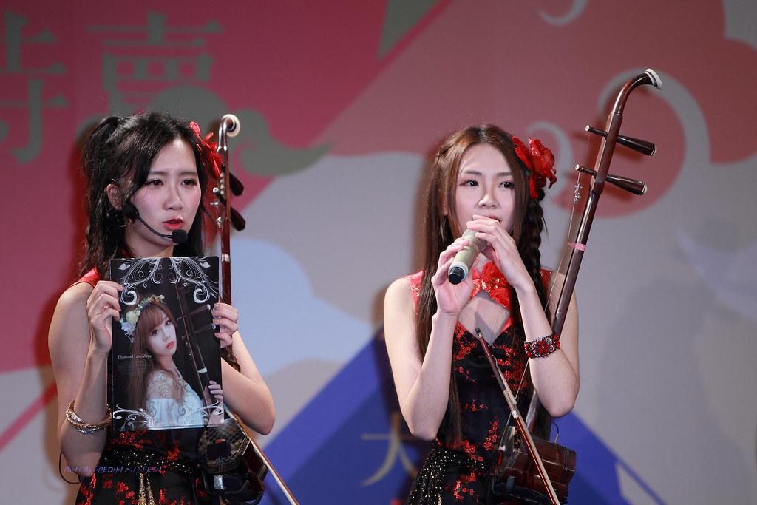

* Make sure that the link ends with **.jpg/.png/…**, which ensures that an image rather than the page address is recorded.

(Consider printing the above page for quick reference as you complete the task!)

**Example**

We here give a step-by-step running example: Suppose that you are a Japanese annotator trying to find photos for the Japanese concept スカート (skirt), ...

**(1) Search engine settings**

The annotator should first open [Google Image Search](https://images.google.com/) and set up the proper environment. The is meant to make sure that the retrieved images reflect the native speakers’ preferences. Hence, for example, the **search language** should be set to Japanese (日本語) and the **search region** to Japan (if the annotator is not located there).   
To do so, issue a search and then click on “Settings” → “Search settings”. Region settings are at the bottom of the page, while the search language can be changed by clicking into “Languages” in the left menu.

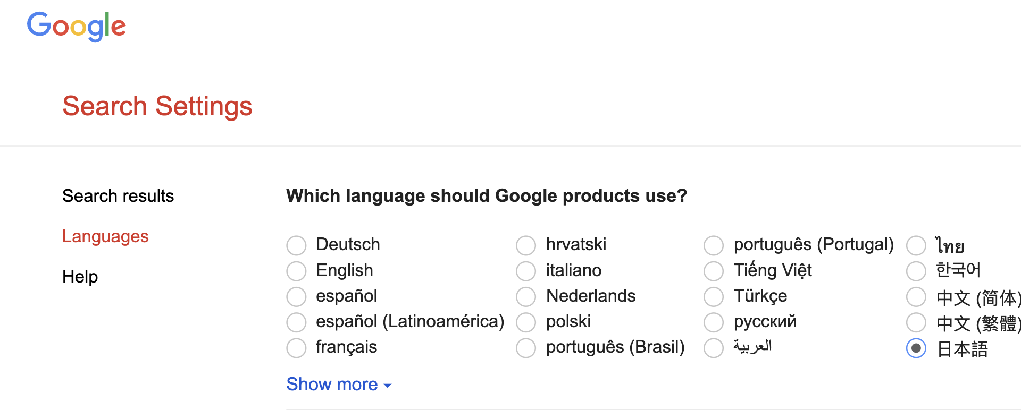

When searching for each concept, the annotator should select to retrieve only photos with CC licenses. To do so, the annotator should click on “Tools” → “Usage rights” → “Creative Commons licenses” (you might need to set this filter **before every search**!).

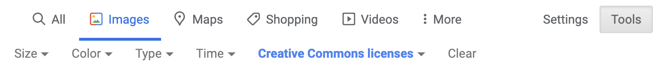

**(2) Photo selection**

When selecting photos, bear in mind the four criteria listed in the last page.

For example, for the concept “**スカート**” (skirt), the annotator should select photos like the first one below, since it “*contains more than one instance*” of “**スカート**” and “*displays a set of diverse objects or features*”.

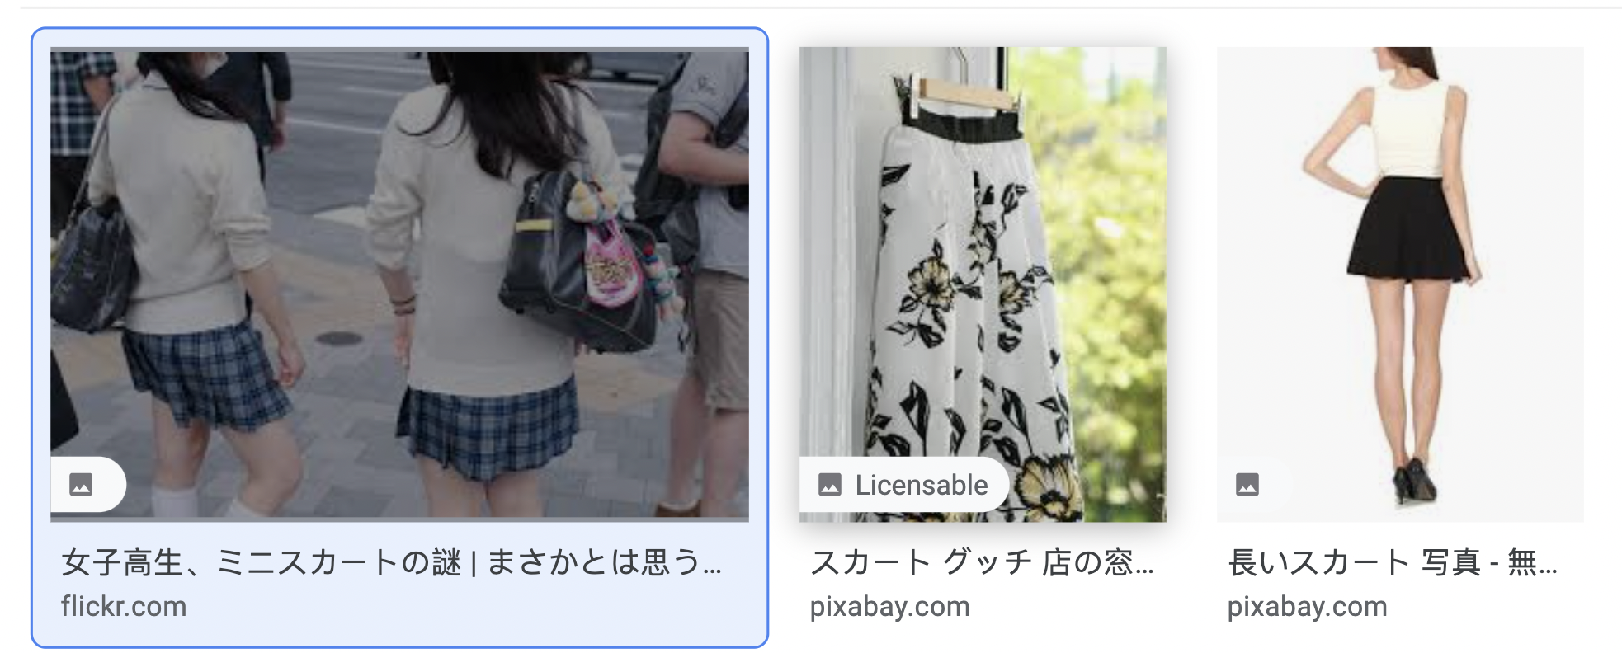

After finding qualified photos, the annotator should write their links by right-clicking the full photos (not thumbnails) and “**copy image address**” and then paste the link (e.g. <https://live.staticflickr.com/3735/8957922959_bbd959e979_b.jpg>) into this document.

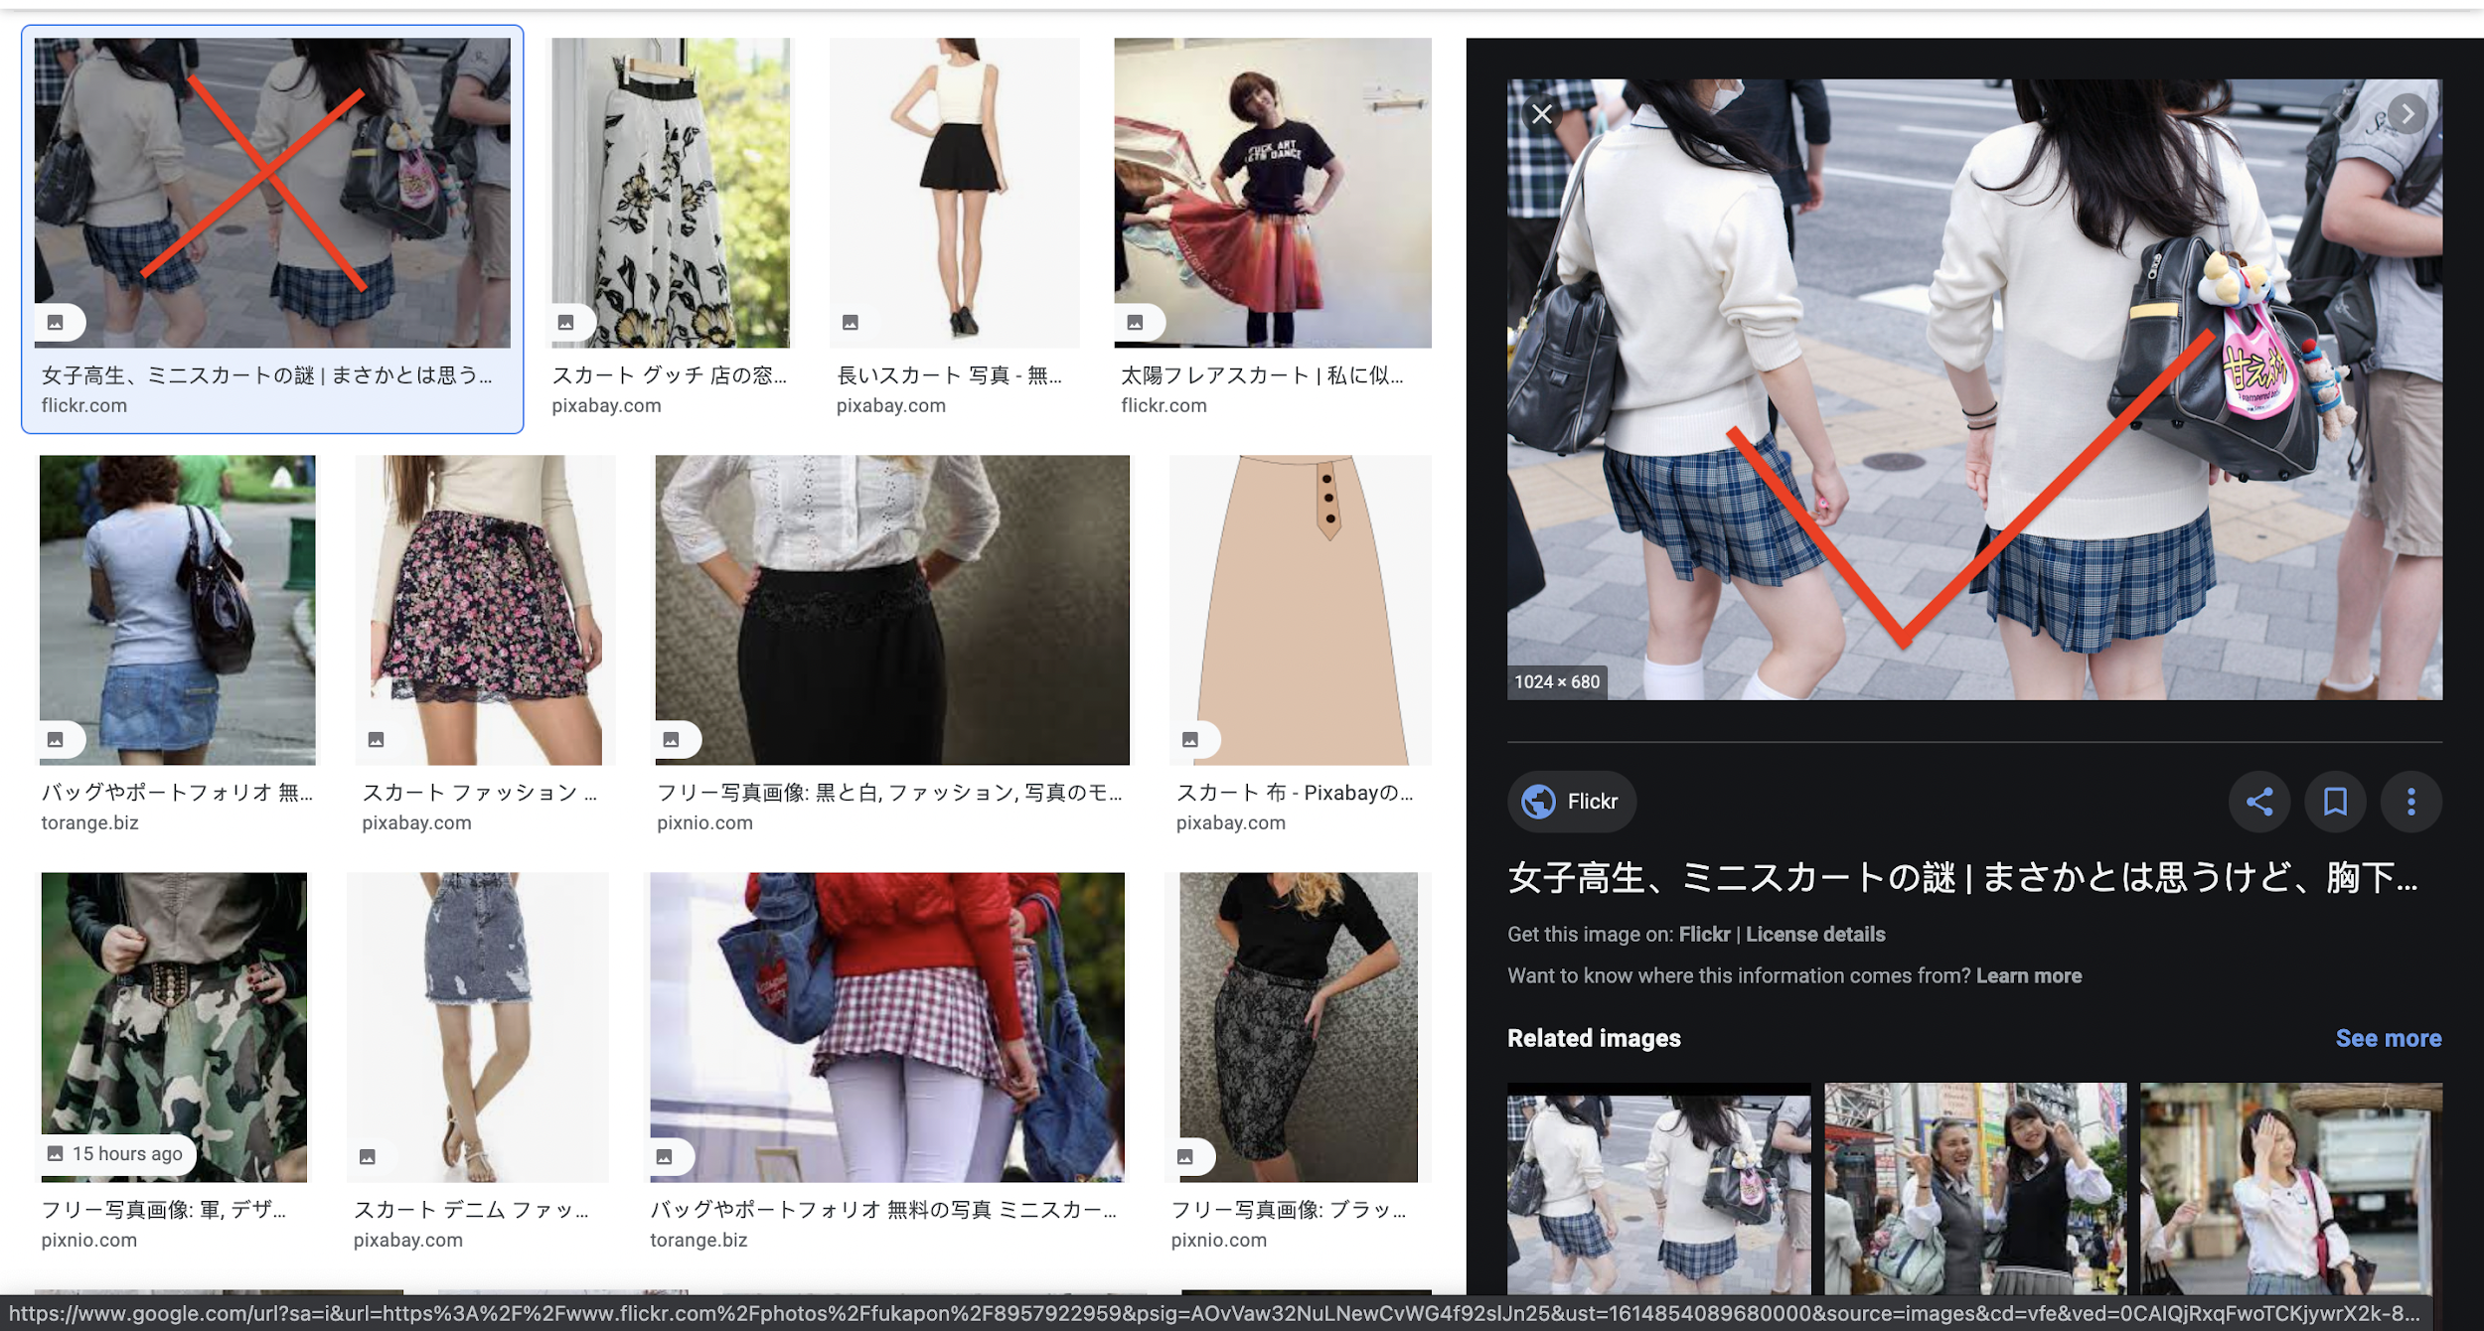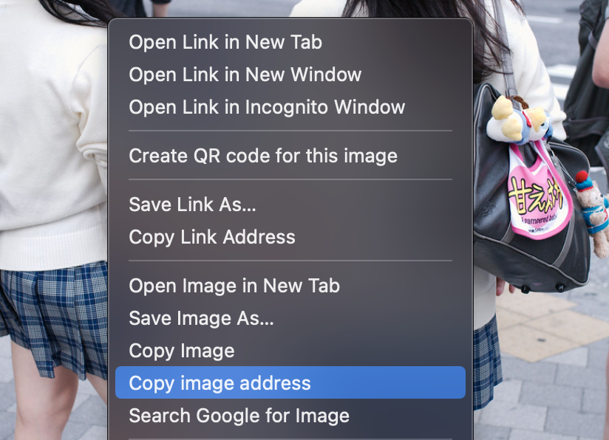

Final tip:

1. In order to find more photos, you are free to use any search engine as long as similar steps are followed.
2. The query used can be anything as long as the photos found meet the requirements. If it’s hard to find enough photos with your native language, you can always use queries in other languages.

## Annotation form:

**************example**************

[[[concept_1]]]

Link_1

Link_2

…….

[[[concept_2]]]

…...

**************************************

**Sample:**

[[[Martı]]]

[[[Basketbol]]]

[[[Rakı]]]

**Full concepts:**

-------- 1 Bird --------

[[[Leylek]]]

[[[Güvercin]]]

[[[Serçe]]]

[[[Martı]]]

[[[Baykuş]]]

[[[Papağan]]]

-------- 2 Mammal --------

[[[At]]]

[[[Kedi]]]

[[[Sığır]]]

[[[Köpek]]]

[[[Koyun]]]

[[[Deve]]]

-------- 3 Flower --------

[[[Gül]]]

[[[Lale]]]

[[[Papatya]]]

-------- 4 Vegetable --------

[[[Kabak]]]

[[[Fasulye]]]

[[[Patlıcan]]]

[[[Ispanak]]]

[[[Hıyar]]]

-------- 5 Sports --------

[[[Basketbol]]]

[[[Voleybol]]]

[[[Futbol]]]

[[[Tenis]]]

[[[Yağlı_güreş]]]

-------- 6 Celebration --------

[[[Kurban_Bayramı]]]

[[[Ramazan_Bayramı]]]

[[[23_Nisan_Ulusal_Egemenlik_ve_Çocuk_Bayramı]]]

[[[Yılbaşı]]]

-------- 7 Utensil/tool --------

[[[Çatal]]]

[[[Bıçak]]]

[[[Tencere]]]

[[[Tava]]]

[[[Tabak_(eşya)]]]

-------- 8 Clothes --------

[[[Pantolon]]]

[[[Etek]]]

[[[Gömlek]]]

[[[Çorap]]]

[[[Tişört]]]

-------- 9 Music instrument --------

[[[Gitar]]]

[[[Piyano]]]

[[[Keman]]]

[[[Kanun_(çalgı)]]]

[[[Davul]]]

-------- 10 Food --------

[[[Sarma]]]

[[[Döner]]]

[[[İskender_kebap]]]

[[[Lahmacun]]]

[[[Baklava]]]

-------- 11 Beverage --------

[[[Ayran]]]

[[[Rakı]]]

[[[Şerbet]]]

[[[Şalgam_suyu]]]

[[[Çay_(içecek)]]]

-------- 12 Fruits --------

[[[Karpuz]]]

[[[Kavun]]]

[[[Portakal]]]

[[[Elma]]]

[[[Üzüm]]]

-------- 13 Types of rooms or areas in a house --------

[[[Mutfak]]]

[[[Oturma_odası]]]

[[[Tuvalet]]]

[[[Banyo]]]

[[[Balkon]]]

-------- 14 Types of buildings --------

[[[Apartman]]]

[[[Villa]]]

[[[Gökdelen]]]

[[[Kulübe]]]

[[[Yalı]]]

-------- 15 Tools in agriculture --------

[[[Çapa_(tarım)]]]

[[[Orak]]]

[[[Kürek_(alet)]]]

[[[Biçerdöver]]]

[[[Traktör]]]

-------- 16 Objects seen in schools --------

[[[Tebeşir]]]

[[[Kara_tahta]]]

[[[Kurşun_kalem]]]

[[[Silgi]]]

[[[Defter]]]

[[[Tükenmez_kalem]]]

-------- 17 Types of visual arts --------

[[[Heykel]]]

[[[Resim]]]

[[[Minyatür]]]

[[[Yağlıboya_resim]]]

[[[Seramik]]]

-------- 18 Religions (e.g. Christian, Buddhism) --------

[[[Yahudilik]]]

[[[Hristiyanlık]]]

[[[İslam]]]

[[[Budizm]]]

[[[Alevilik]]]